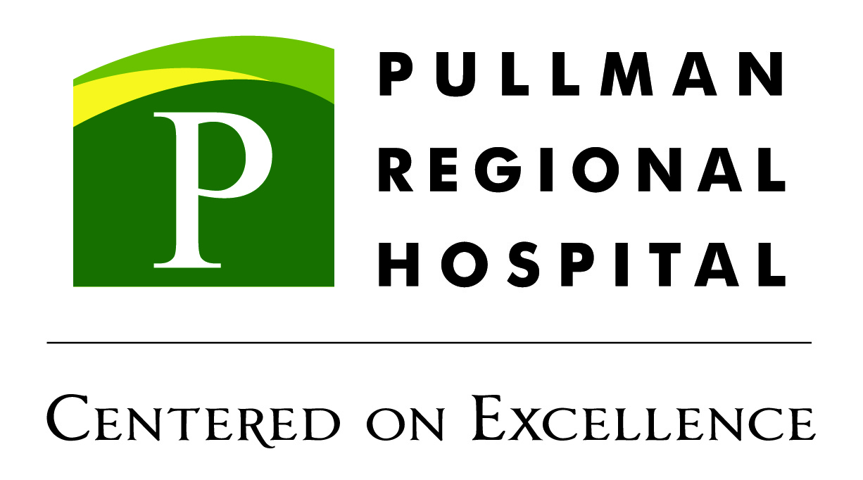
BirthPlace Visitation:
- Visitors will be screened prior to admittance to the hospital and must be without symptoms of cough, fever, body aches, or respiratory symptoms. Wearing a mask is still a requirement.
- A Healthy patient's visitors:
- Maximum of 2 visitors/support person(s). It must be the same 2 people for the entire patient stay. BP bands will be provided for each support person/visitor.
  - The primary support person:
    - Primary support person can stay 24/7.
    - Meals provided for primary support person only.
  - Back up support person/visitor:
    - A backup support person can stay outside of visiting hours until the patient delivers and is recovered.
    - After recovery visitor #2 must limit visitation to regular visiting hours.
- Visitors may leave and return. They are asked to limit contact with the public while out of the facility.
- A patient that is symptomatic, under investigation or Covid positive is allowed one visitor for the entire stay (who must remain in the room at all times).
- No visitors under 12 (siblings included).

BirthPlace Masking:

- Masks are required to be worn anytime a patient or support person is outside their assigned room or when a health care worker is in the room.
I understand and agree to the above visitation and masking guidelines.

Patient: _________________________________________ Date: _______________________

Support Person : _______________________________________________ Date: _______________________

Support Person : _______________________________________________ Date: _______________________

