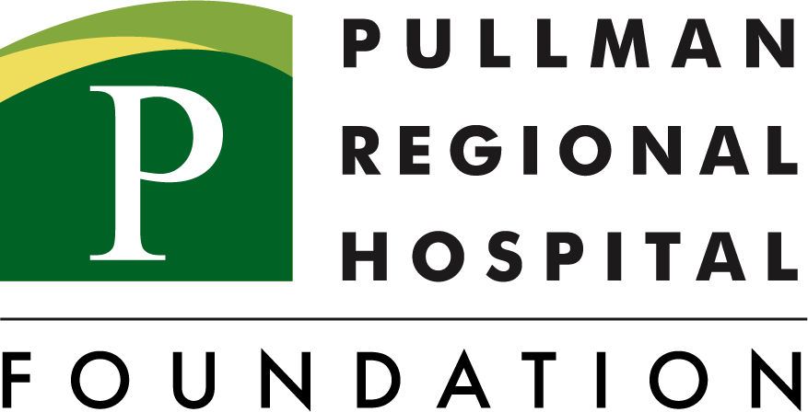

“GENEROSITY AT WORK”
EMPLOYEE GIVING CAMPAIGN 2022

EMPLOYEE PAYROLL DEDUCTION/GIVING FORM

Name _____________________________________________________________________
Address _____________________________________________________________________
City, State, Zip ________________________________________________________________
Phone: (Work) _____________ (Home) _____________ Personal Email: _________________

I would like to donate the following amount per pay period*:

$ _______ (minimum $5 per pay period)

All gifts are deducted until further notice.

*NOTE:
□ This replaces my current payroll deduction OR □ This is in addition to my payroll deduction

One-time gift in the amount of $ _________________
□ Attached is my check
□ Please charge my credit card
Card Number _______________________ Expiration Date: ________________

How would you like your name listed in donor recognition materials?

(Please Print) ________________________________________________________________

Signature __________________________________________ Date ___________________

Please fax or return this form to:
Pullman Regional Hospital Foundation
Stephanie Pierce, Director of Development, Annual Giving
Corporate Pointe, Suite 200
Office (509) 332-2044 | Fax (509) 332-2111

Internal Use Only
Foundation Staff: _________________ Date: ______________
HR Staff: _______________________ Date: ______________
Deduction Start Date: ____________________
Per Pay Period Deduction Amount: _________ Annual Deduction Amount $ _________

PRH Foundation will provide employee with copy of completed pledge.
Gifts are tax deductible to the extent provided by law.

