BREAKFAST SPECIAL: Country Fried Steak Croissant Sand Biscuits and Gravy Breakfast Burrito Chef’s Choice
 | Mon | Tue | Wed | Thu | Fri | Sat
Mediterranean Week  The highlighted items are included with the meal and not charged separately. | 1 Lunch  Baked Salmon Bowl with Quinoa and Tzatziki  Tarragon Carrots  Pizza  Tomato Bisque | 2 Lunch  Chicken Cordon Bleu w/swiss cheese sauce  Callista Cobb Salad w/herb focaccia  Insalata D’Orzo (side dish)  Pizza  Chicken Noodle Soup | 3 Lunch  Feisty Feta Chicken Pasta  Falafel Sandwich  Black-eyed peas  Pizza  Red Pepper and Gouda Soup | 4 Lunch  Mediterranean Flatbread  Grilled Chicken Caesar Salad  w/breadstick  Pizza  Mushroom and Brie Soup | 5  Avocado Provence Chicken Wrap  Quinoa tabbouleh  Garlic green beans  Pizza  Clam Chowder | 6
7  African Week | 8 Lunch  Walnut Crusted Chicken  Collard Greens w/tomatoes  Pizza  Tomato Bisque | 9 Lunch  Vegetable Curry  Balsamic Steak Salad w/herb focaccia  Pizza  Fiesta Chicken Soup | 10 Lunch  Shrimp Gumbo w/rice  Grilled Chicken Caesar Salad  w/breadstick  Pizza  Red Pepper and Gouda Soup | 11 Lunch  Herb-Crusted Tilapia Green Beans  Hoppin Johns Salad w/whole wheat roll  Pizza  Mushroom and Brie Soup | 12 Lunch  Chicken Yassa  Garlic spinach  Jagacida (rice and beans)  Pizza  African Peanut Soup | Sun
14  Latin American Week | 15 Lunch  Baja Fish Tacos  Beans and Greens Blend  Pizza  Tomato Bisque | 16 Lunch  Chicken Tinga w/rice  Balsamic Steak Salad w/herb focaccia  Pizza  Chicken Noodle Soup | 17 Lunch  Grilled Steak w/Chimichurri  Vegan Taco Salad Pizza  Red Pepper and Gouda Soup | 18 Lunch  Quinoa Stuffed Peppers  Grilled Chicken Caesar Salad w/breadstick  Pizza  Mushroom and Brie Soup | 19 Lunch  Chicken Enchilada Bowls  Pizza  Clam Chowder | 20  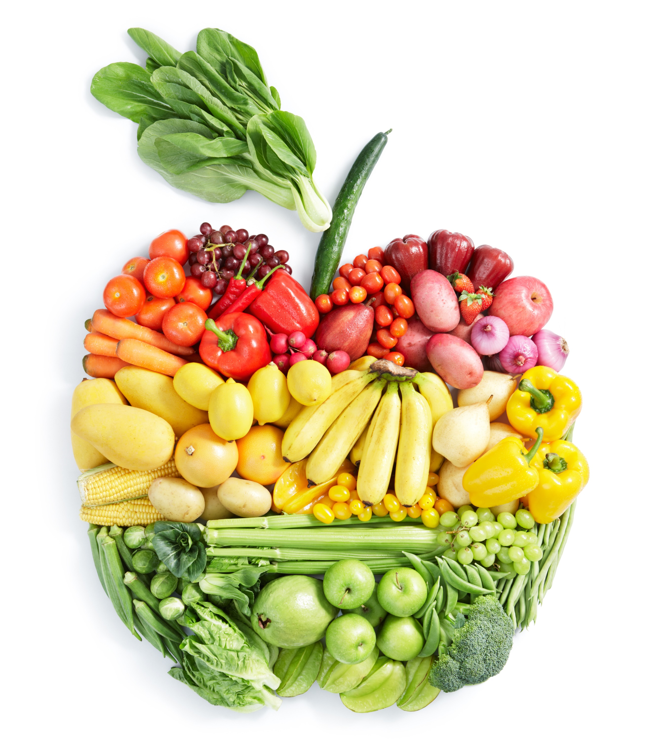
21  East Indian Week | 22 Lunch  Butter Chicken w/basmati rice  Mango Kale Salad  Pizza  Tomato Bisque | 23 Lunch  Aloo Gobi  Balsamic Steak Salad w/roll  Pizza  Fiesta Chicken Soup | 24 Lunch  Dal Makhani  Grilled Chicken Caesar Salad  w/breadstick  Pizza  Red Pepper and Gouda Soup | 25 Lunch  Ladakhi Chicken Thukpa  Quinoa Rocket Leaves and Chickpea Salad  Pizza  Mushroom and Brie Soup | 26 Lunch  Korma w/rice  Pizza  Chef’s Choice | 27
28 | 29  Philly Cheesesteak Sandwich  Pizza  Tomato Bisque | 30  Mac & Cheese  Balsamic Steak Salad w/roll  Pizza  Chicken Noodle Soup | 3 Lunch  Cheese Enchiladas  Grilled Chicken Caesar Salad  w/breadstick  Pizza  Red Pepper and Gouda Soup

March
Red Sage Menu

2021

